THE FUTURE OF FINANCE SKILLS……
THE
NEED

Traditional career paths have been disrupted by an increased push for efficiency throughout the industry, right from small trader to large multinational conglomerate.
Automation that were beyond our imagination are now part of our day-to-day personal and professional life. So as technology is cannibalizing itself, what is relevant today is going to change completely in the near future.
Given the current economical downtrend and stress in the world economy. There will be a huge pressure on everyone to increase the efficiency i.e cost reduction!
Finance and Accounting (F&A) is no different, this sector is horizontally cutting across all the industry and business verticals. Right from Cashier in the small shop to the space research center…. Finance and Accounting is everywhere.
Our Education system is Horizontal. Whereas skills in demand is Vertical
Our existing education system is horizontal , taking an example of B.Com/ M.Com curriculum. The length and breadth of the entire syllabus covers everything from Accounting – Economics – Micro/ Macro, Business Studies, Costing, Banking Finance , Management accounting , etc.
Whereas Skills in demand is very specific to only one area that further needs specialization. According to experts, around 90% of our educated population eligible for Job are not digitally and technically empowered.
So, here are the key skills that you need to survive and succeed in the future
- Re-skill to upskill
The most important attitude one should carry is continue to Re-skill to upskill herself. As I mentioned above; technology is cannibalizing itself and hence what is best today may not exist tomorrow. Best examples are Pager , Nokia Pone, old cameras, cashers are replaced, ATM and ATMs nearly replaced with digital and plastic money.
- Software – End user skills
One must know following accounting tools before s/he is ready to hit the job market.
ERP Certifications- SAP, Oracle, PeoplSoft, JDEdwards are some of the largest financial software’s globally used by multinational companies. There are online/ offline training institutes that provide training and project works with Job assistance
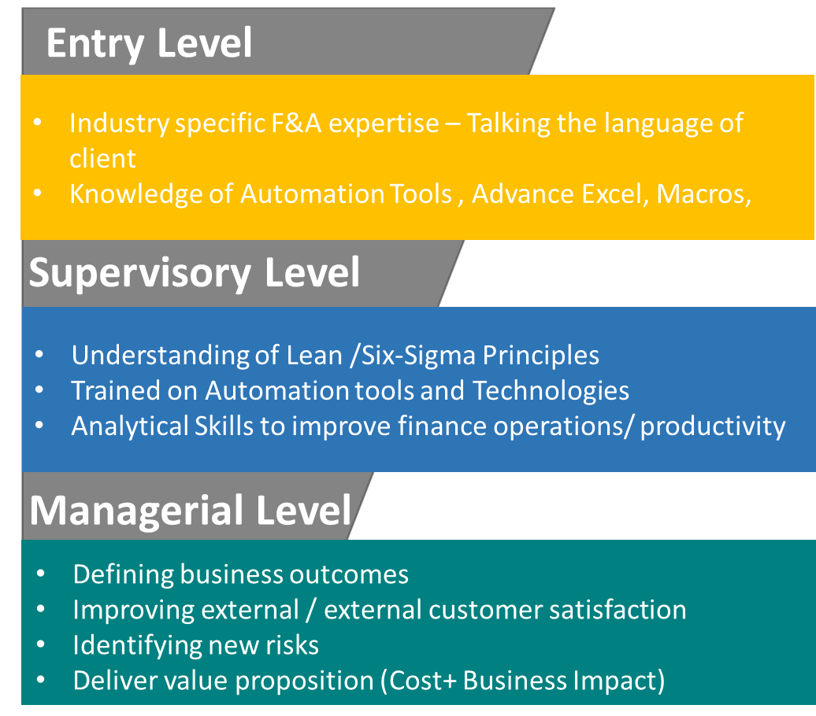

- Analytical Skills
While many skills in accounting can be obtained overtime, through on the job experience. Obtaining additional skills during the first 1-3 years of service is the key for success. And the best way is to pursue certification courses in Analytics that will give booster to your career. These courses are – are related to
- Financial planning & Analysis.
- Data visualization
- Forecasting , budgeting,
- Management reporting,
Supported by Business Intelligence and analytical tools like Python, SAP- BW, Oracle- Nvision, etc.

- Process Automation Knowledge
There is huge demand of accountants who are abreast and trained beyond the accounting skills. And Automation is the key area every accountant must focus on. There is a reason to it… cost remains the center of focus. And hence efficiency is always the starting point, delivering maximum output with optimized resources is always the first target. Every repetitive, monotonous, standard work process is getting automated and as a end user accountants are the best people who can identity and automate the work. There many tools and certifications in the market. Blue Prism, UiPath, Automation Anywhere are few examples. These certifications are available online/ offiline with project works. Demand for such Techno Accountant skills is very high with excellent pay and future

- Lean, Six Sigma
Beyond Automation , there are many fragmented processes that has upstream and and down streams with other functions in the organization. It is imperative to work in the leanest way and avoid any sort of wastage of waiting time, non-value add steps, reduce handovers, etc. To solve these problems, one must have ability to critically analyze and improve the process. Developing expertise in six sigma can help aspiring or current managers take their careers to the next level. There are many certification courses like, Six- Sigma, DMO, lean, yellow-belt, Green belt and Black belt certification courses
- Story Telling
Industry is falling short of managers who can implement lateral thinking and present point of view in a simple words, ability to convince ,explain internal external stakeholders, business etc. Story telling is a great art to develop persuasion and advocacy. It focuses on bigger picture and helps the audience to emotionally connect with the subject. You will learn these skills over the professional journey
Conclusion
In the coming years, some technical skills will increase, and few will decrease, and new skill will be required, which will vary across industry sectors. Accountants in particular domain will need customized support to help them to develop. Globalization has reduced the distance between the people and so as most of us interact , chat, email , attend conference, webninars, seminars , that needs great Interpersonal and communications skills for those are moving up in the ladder from a doer- to getting the work done. Many newly qualified accountants, graduates lack the people management skills to deal constructively with peers, supervisor and their subordinates. Speaking the language of finance is no longer enough. Rather speaking the language of business is. Finance and Accounting function within the organization is continuously shifting from mere cost effective & reactive to strategic and proactive. There is huge demand of accountants who are abreast and trained beyond the accounting skills.

Author is professional trainer in Finance & Accounting, he has over 21 years of experience in Finance Operations, he has worked with top 10 ITES companies – Infosys, Genpact, Tata Consultancy Services. He runs Finance and accounting training institute based out in Pune.

